Add in Remark colunm to indicate “ STGC “

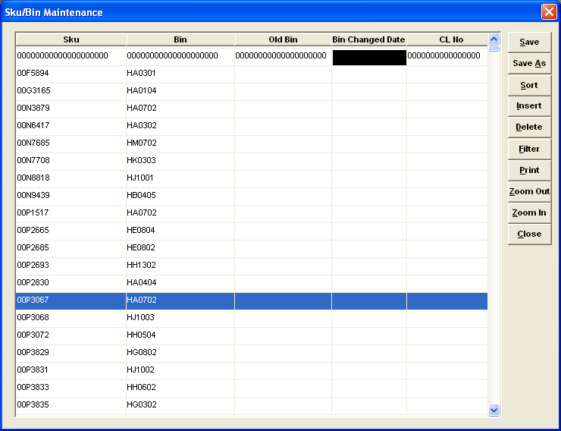

Upload data base to add in the for Sku , Bin , Old Bin & remark column

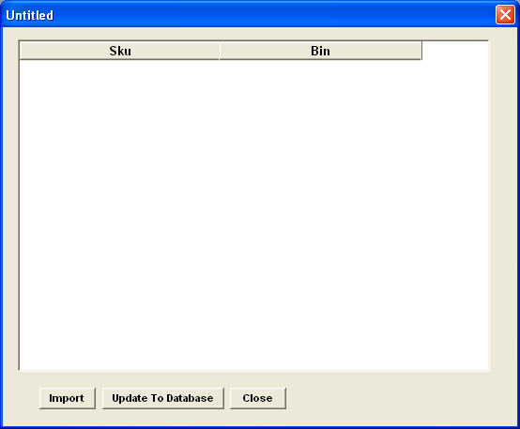

Add in label upfront as remark to reflex STGC for both database

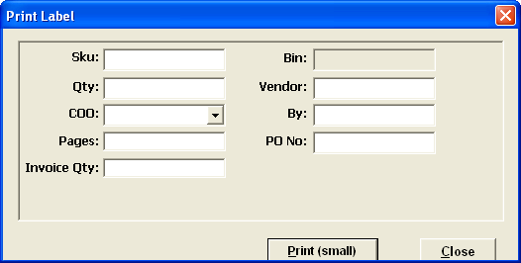

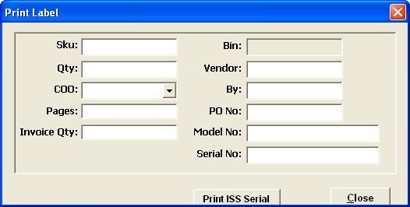

Current Label – Qty reflex not enough space for mare than 5 digit (10,000)
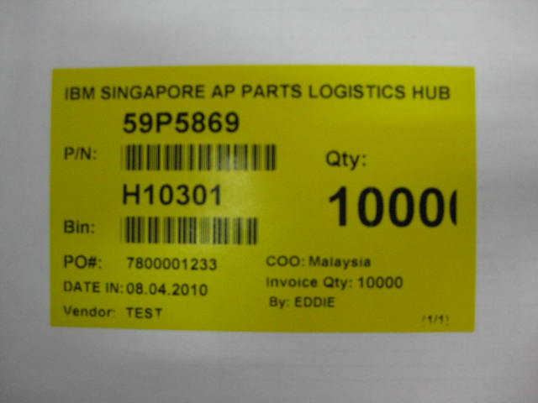

Propose label to implement – STGC to shown on label.
Qty to show 5 digit in full

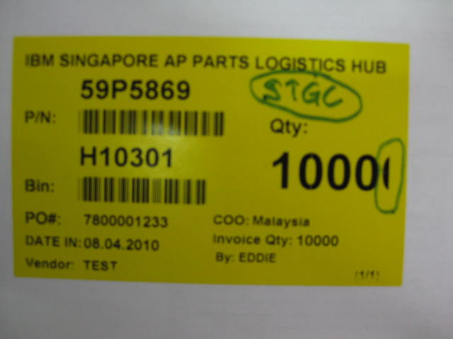

Changes DONE:

- SKU/Bin Maintenance
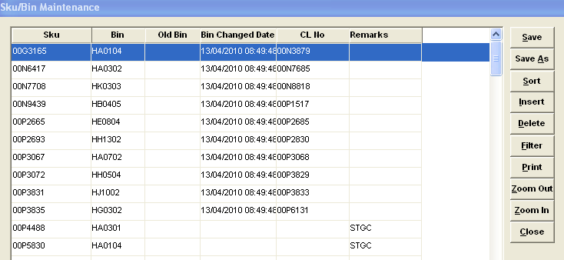

- Import SKU/Bin
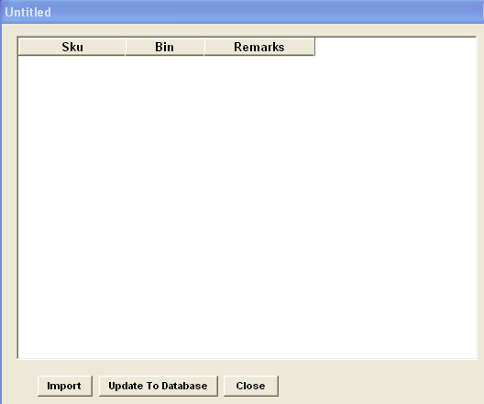

- Print Label
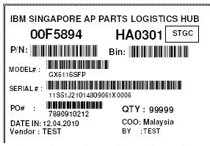

- Print ISS Label
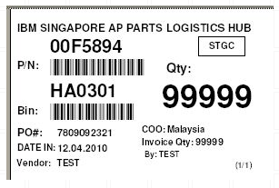
- Audit report – add remarks
